PROJECT REPORT TEMPLATE

***1.Introduction***

***1.1 Overview***

My project is about

graphic designing with

Canva(Resume)

***1.2 purpose***

Through this canva

use for editing.

***2.problem definition and design Thinking***

***2.1 Empathy Map***

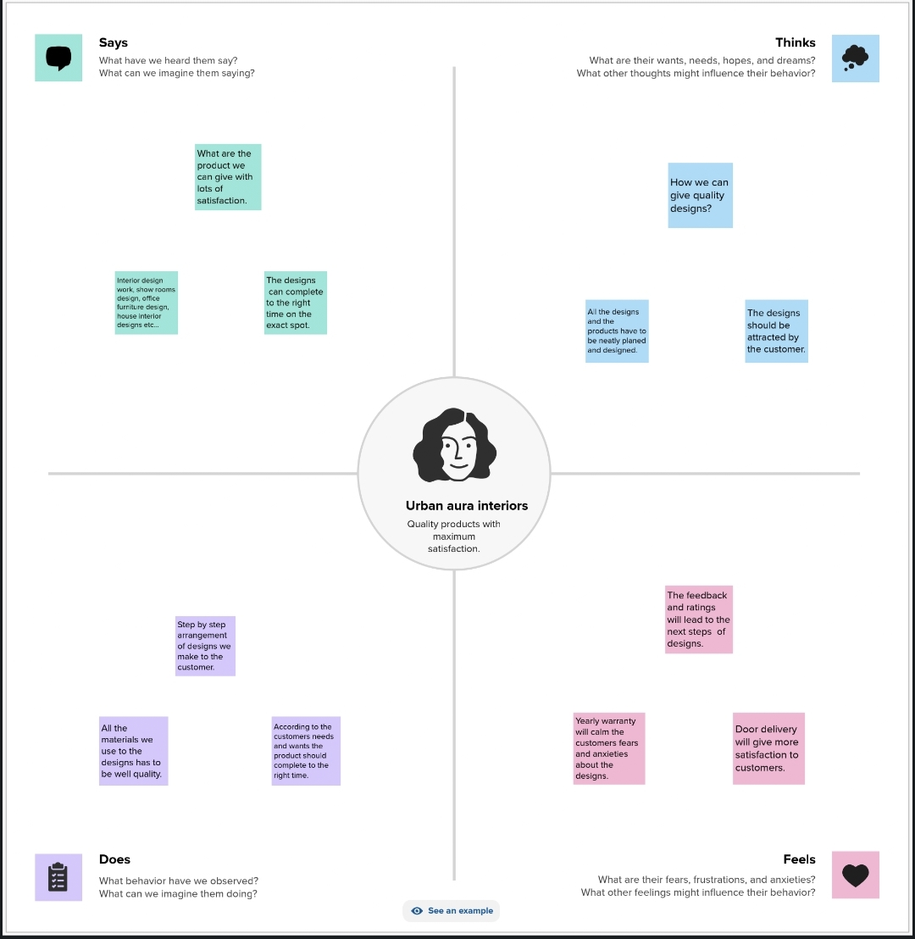

***2.2 Brainstorm Map***

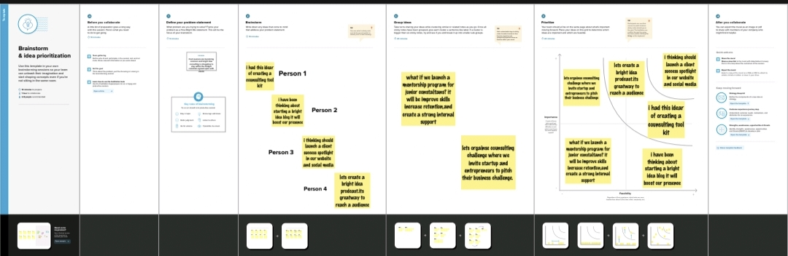

***3.Result***

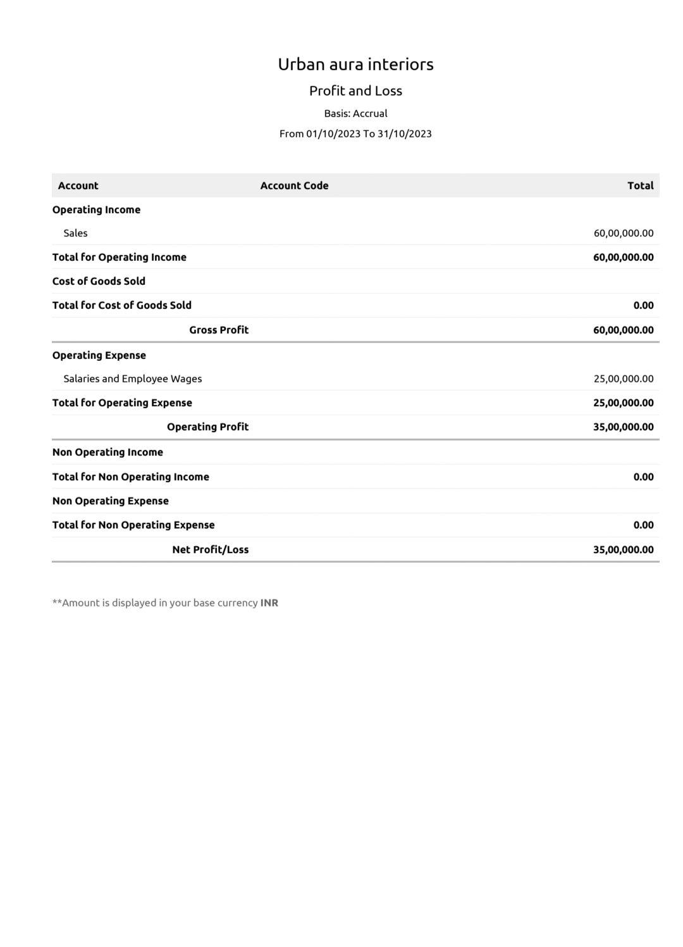j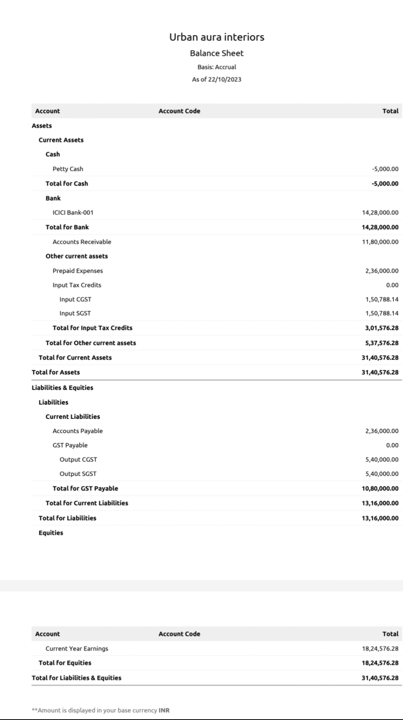

***4.Advantage & Disadvantage***

This is very useful for us even

a non designer Can become

a designer using canva.

Disadvantage there are lots

of premium are there.

***5.Application***

This canva application is

application is helpful for

college students,and also

for entrepreneur

***6.conclusion***

This canva is very helpful to

our personal use and study

purpose.

Through this canva we

can learn so many things.

***Thank you.***